Complete guide to building an app with net core and react

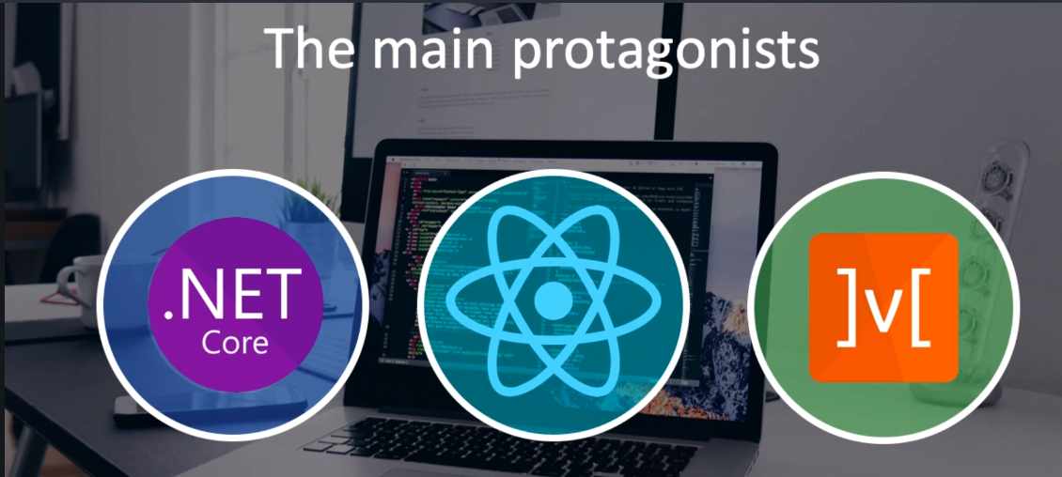



.dotnet core sdk 3.x

dotnet –info

dotnet –version

* node.js ( <https://nodejs.org/en/>)
* Installing node.js with NVM ( <https://medium.com/@Joachim8675309/installing-node-js-with-nvm-4dc469c977d9>)
* Install git
* Vscode
* Vscode Extensions
  + Auto close tag
  + Auto Rename Tag
  + Bracket pair colorizer2
  + C# power by omnisharp
  + C# extension (jchannon)
  + Es7 React/Redux/Graph …
  + Material icon theme
  + Nugget package manager
  + Prettier code formatter
  + SqLite

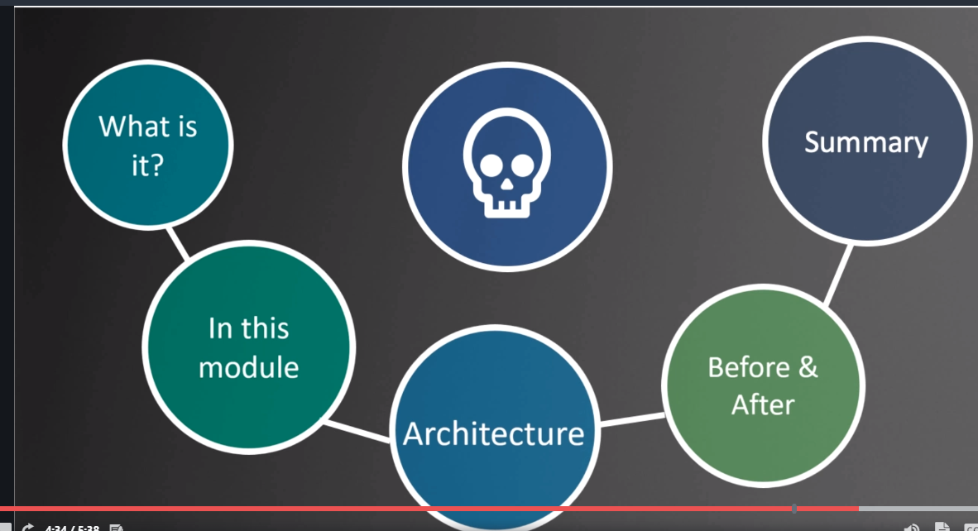

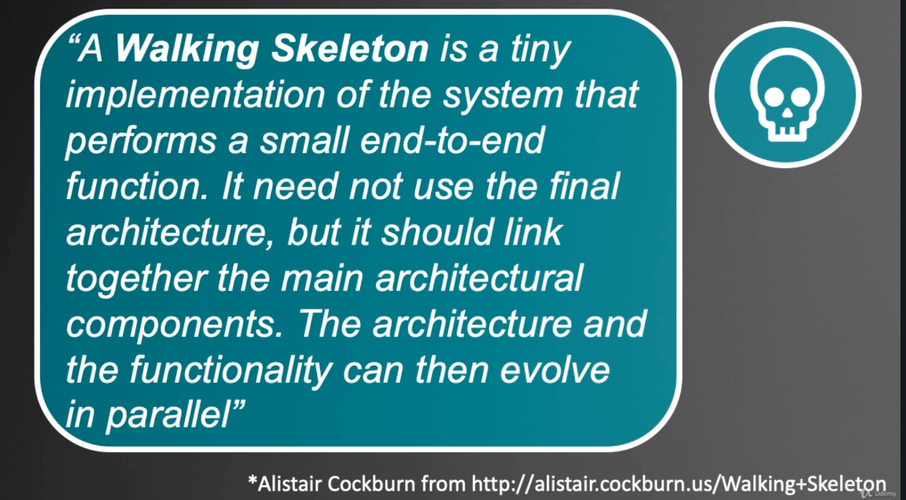

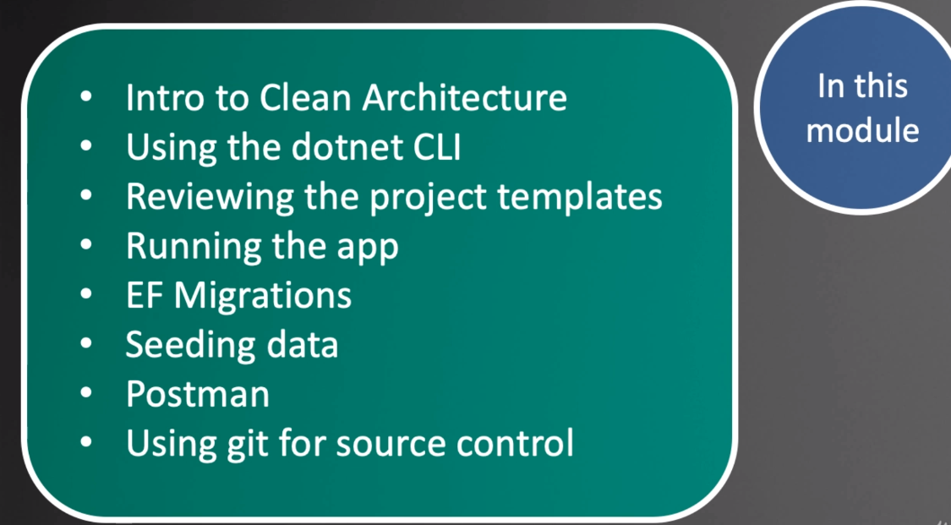

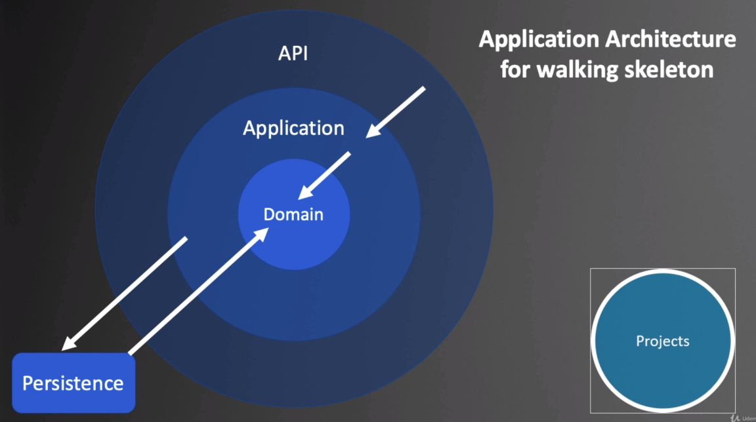

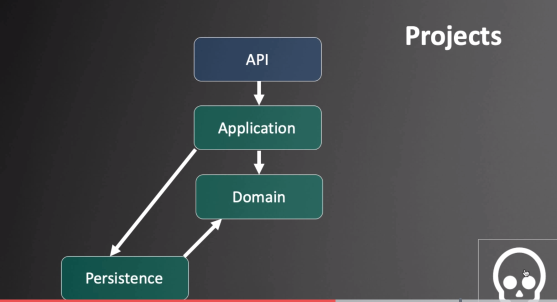

dotnet –info

mkdir Reactivities

dotnet –h ( list the command )

dotnet new –h

dotnet new sln ( will use the name of containing server for solution name)

dotnet new classlib –n Domain

dotnet new classlib –n Persistence

dotnet new classlib - n Application

dotnet new webapi –n API

Adding dependencies:

dotnet sln –h

dotnet sln add Domain/

dotnet sln add Persistence

dotnet sln add application

dotnet sln add API

Cd to the Application project use dotnet add reference …

